Learners have to develop a Report to support the answers to the following questions and suggestions.

Objective Questions:
- What is the total number of attributes in the customer table?

“Orders” sheet has 17 attributes (order date, order ID, delivery date, customer ID, location, zone, delivery type, product category, sub category, product, unit price, shipping fee, order quantity, sale price, status, reason, rating) & “Customers” sheet has 3 attributes (customer ID, customer age, customer gender)
- How will you get the “Customer’s” ages in the “Order” tables according to customer IDs?

I established a relationship between the “Customers” and “Orders” tables using customer ID. This allows me to access customer attributes like Age directly in the Orders context.
- In analyzing the dataset with Power BI, ensure data cleaning to address inconsistencies and missing values before further analysis.

- Before performing analysis in Power BI, I carried out data cleaning in Power Query. I ensured correct data types for columns such as dates and numeric fields.
- Handled missing values by replacing nulls in the ‘Reason’ column with ‘No Issue’ and removed duplicate records from the Customers table based on customer ID
- Created a derived column “Delivery Days” to measure delivery performance.
- I cleaned text fields by trimming and removing unnecessary spaces to maintain consistency. This ensured accurate and reliable analysis.
- How can we calculate the total revenue generated by all the sales?
“Total Revenue” is be calculated by summing the Sale Price column using a DAX measure.
- What is the total number of unique customers who made purchases each year? Is there any increase in the number over the years?

APPROACH
The “Total Customers” (unique) each year can be calculated using DISTINCTCOUNT on customer ID using DAX.

Which could also look like:

The “Year” column, created in Power Query is used to group the data annually.

Which could also look like:
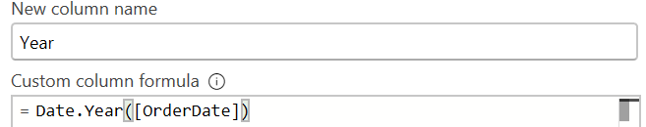

OBSERVATION
- Customer count remains stable (17.4K - 17.7K) from 2015 - 2019.
- Significant increase in 2020, jumping to 25.2K. This is an increase of 7.5K customers (43% growth YoY)
Which could also look like:
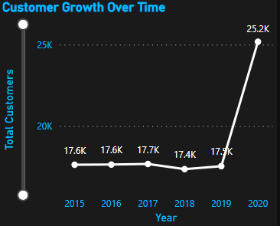

RECOMMENDATION
NIL

- How can we determine the total number of unique products available in the company?

The total number of unique products can be calculated using DISTINCTCOUNT on the Product column using DAX.

Which could also look like:
- What is the average number of days it takes for products to be delivered, get the metric for only the delivered orders.
The average delivery time for delivered orders can be calculated by taking the average of delivery days while filtering only records with status as “Delivered” using DAX.

Which could also look like:
- Which products, categories, and subcategories are the most popular?
The most popular products, categories, and subcategories can be identified by analyzing total orders using bar charts and sorting them in descending order.

Which could also look like:

Which could also look like:
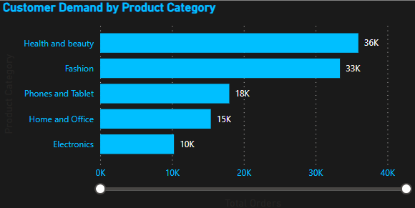

- Which products have seen an increase or decrease in sales over the year?

APPROACH
To evaluate product performance over time, a Year-over-Year (YoY) analysis was conducted by first deriving an Order Year column from the Order Date.

Which could also look like:

A DAX measure was then created to calculate the percentage change in revenue between the current and previous year, ensuring missing prior-year values returned zero to avoid inaccuracies.

Which could also look like:
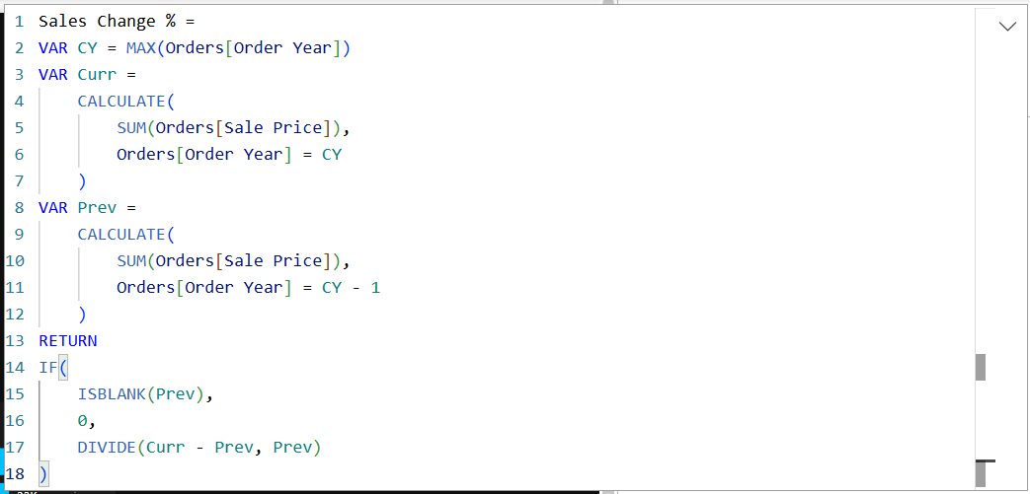

A bar chart was then used to visualize category wise YoY growth across all available years, enabling comparison of performance trends over time.

Which could also look like:
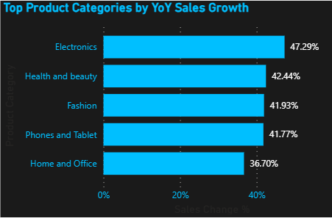

OBSERVATION
All categories show positive growth, indicating overall business expansion.
- Electronics leads with 47% growth, highest among all categories.
- Health & Beauty (42.4%) and Fashion (41.9%) show strong consistent growth.
- Phones & Tablet (41.8%) indicates stable performance.
- Home & Office (36.7%) shows the lowest growth.
Growth variation ranges between 36% to 47%, indicating overall upward trend.

RECOMMENDATION
- Leverage Electronics growth (47%) by optimizing pricing to improve revenue conversion.
- Continue investing in Health & Beauty & Fashion (42%), as they drive both demand and growth.
- Improve Home & Office (7%) through targeted promotions and repositioning.
- Conduct product level analysis within categories to scale high-performing SKUs.

- While modeling the data relationships, what will be the type of relationship between the customer ID of Orders and customer tables?
- The relationship between the Orders and Customers tables is a Many to One relationship, where multiple records in the Orders table correspond to a single record in the Customers table.
- This is because one customer can place multiple orders, making Customer ID a foreign key in the Orders table and a primary key in the Customers table.
- The relationship is set with a single-direction filter, allowing customer attributes such as age and gender to filter and analyze order-level data effectively.
- How have you handled the null values in the data?
Data cleaning was carried out in a structured sequence to maintain data integrity:
- Duplicate Handling:
Duplicate records were first identified and removed from both the Customers and Orders tables using Customer ID as the reference key, ensuring uniqueness and eliminating redundancy.
- Null Value Treatment:
Post deduplication, null values were observed only in the “Reasons” column. Since this field represents customer-reported issues, blank entries were considered meaningful (i.e., no issues reported) rather than missing data. Therefore, instead of removing such records, null values were replaced with “No Issues” to improve interpretability while preserving the dataset.
- Were there any data format issues in the data, and if there were/are how you would handle them?
There were no significant data format issues in this dataset, but if present, I would handle them in Power Query by assigning correct data types and standardizing formats to ensure accurate analysis.
- When we add a column in Power Query what’s the code that comes in M language in the formula bar? What do you know about M-query?
When adding a column in Power Query, it generates an M expression using “Table.AddColumn”, where we define the new column and row-level logic using ‘each’. M Query is a functional, step-based language used for data transformation, where each step builds on the previous one and all operations are recorded as reusable expressions.
- Identify the top 5 most valuable customers using a composite score that combines three key metrics: (SQL)
  - Total Revenue (50% weight): The total amount of money spent by the customer.
  - Order Frequency (30% weight): The number of orders placed by the customer, indicating their loyalty and engagement.
  - Average Order Value (20% weight): The average value of each order placed by the customer, reflecting the typical transaction size.

APPROACH
The cleaned dataset was first prepared in Power BI Desktop using Power Query. Post cleaning, the transformed data was exported by copying it into Excel and saving it as CSV files, with each logical table maintained separately.
To enable structured querying and analysis, corresponding empty tables were created in MySQL Workbench:

*Query as Screenshot is attached *
Orders
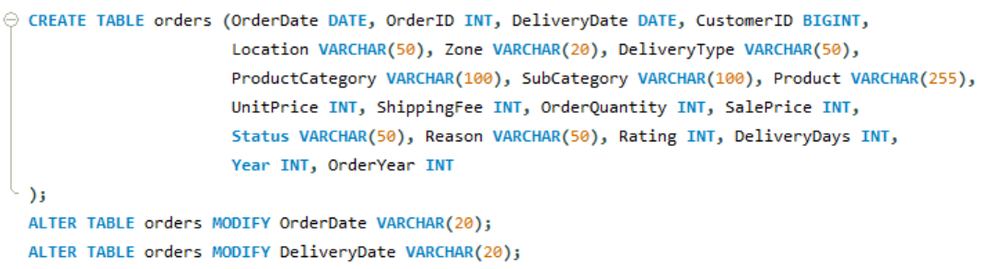

Customers
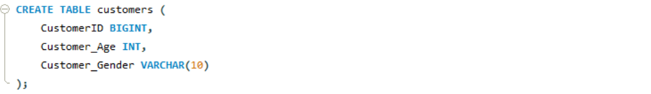

The prepared CSV files were then imported into the database using the Table Data Import Wizard, ensuring accurate and efficient ingestion of cleaned data for downstream SQL-based analysis.
OBSERVATION
To identify the top 5 most valuable customers, a composite scoring approach was implemented based on three key business metrics:
- Total Revenue (50%)
- Order Frequency (30%)
- Average Order Value (20%)

Since these metrics operate on different scales, normalization was applied using max-scaling to ensure fair contribution of each factor.

*Query as Screenshot is attached *
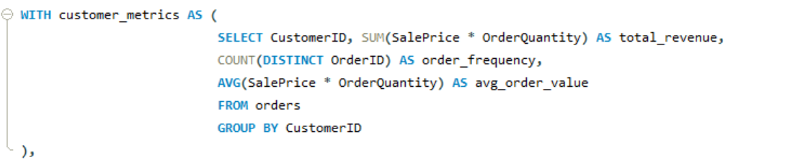
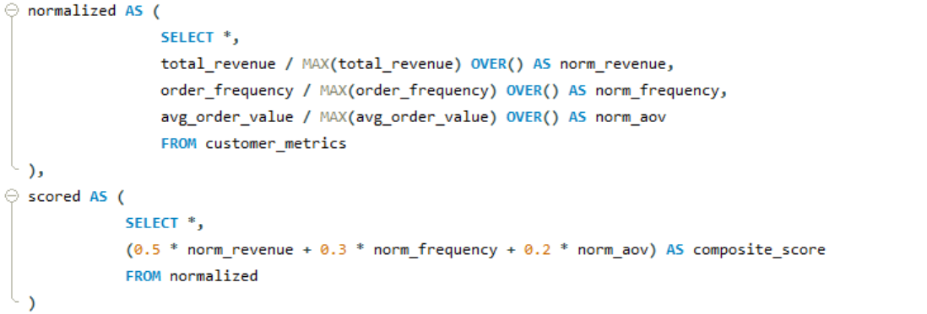
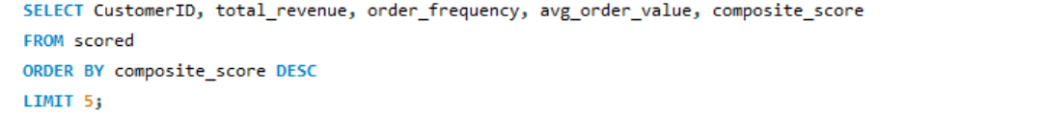

*Output as Screenshot is attached *
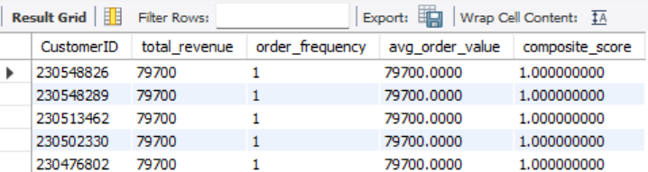

RECOMMENDATION
NIL
- Calculate the month-over-month growth rate in total revenue across the entire dataset. (SQL)

APPROACH
The cleaned dataset was exported from Power BI and stored as CSV files, which were then imported into MySQL using the Table Data Import Wizard. Since the OrderDate column was stored as a VARCHAR in the format dd-MMM-yy, it was first converted into a proper date format using STR_TO_DATE. An aggregation query was executed.

*Query as Screenshot is attached **
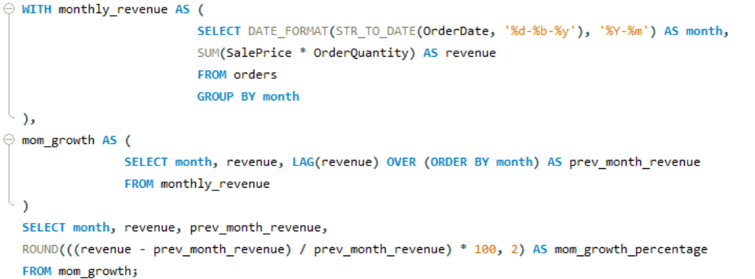

OBSERVATION

*Spreadsheet is attached*

*Output as Screenshot is attached *
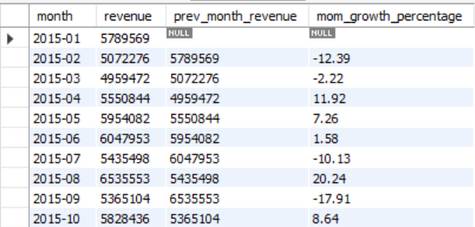

The MoM analysis shows a highly fluctuating revenue trend with frequent increases and declines, indicating volatility rather than steady growth. There are recurring dips in certain periods (early-year and mid-year), suggesting possible seasonality.

The business also demonstrates strong recovery phases, with sharp positive spikes following declines. However, 2020 stands out as an anomaly, with extreme growth in January (+163%) followed by a steep drop in June (-56%), indicating external disruptions or one-time events.

RECOMMENDATION
- Plan targeted promotions during low performing months to counter seasonal dips.
- Replicate strategies from high growth periods to sustain revenue.
- Investigate 2020 anomalies to understand external impacts and improve forecasting.
- Implement loyalty programs or recurring revenue strategies to reduce volatility.
- Calculate the rolling 3-month average revenue for each product category. (SQL)

APPROACH
To calculate the rolling 3-month average revenue for each product category, an aggregation query was executed.

*Query as Screenshot is attached *
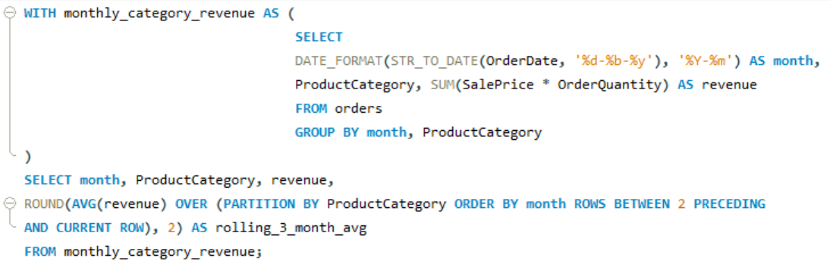

OBSERVATION

*Spreadsheet is attached*

*Output as Screenshot is attached *
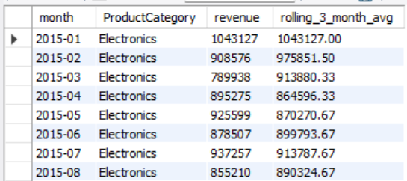

The rolling 3 month average smoothens short-term fluctuations and reveals clearer trends across product categories.
- Phones and Tablet consistently generated the highest revenue but also showed high volatility, especially with sharp spikes in 2020.
- Electronics demonstrated moderate fluctuations with relatively stable growth patterns over time.
- Fashion and Home & Office showed steady but less volatile performance, indicating consistent demand.
- Health and Beauty remained the most stable category with minimal variation in revenue.

Across all categories, 2020 shows noticeable spikes followed by sharp drops, indicating external disruptions impacting sales patterns.

RECOMMENDATION
- Focus on stabilizing high revenue but volatile categories like Phones and Electronics through inventory and pricing strategies.
- Leverage consistent performers (Fashion, Home & Office) for steady revenue streams.
- Investigate 2020 fluctuations to understand external impacts and improve forecasting.
- Use rolling averages in dashboards to support trend-based decision making rather than relying on raw monthly fluctuations.
- Update the orders table to apply a 15% discount on the `Sale Price` for orders placed by customers who have made at least 10 orders. (SQL)

APPROACH
To identify such customers, an aggregation query was executed.

*Query as Screenshot is attached *
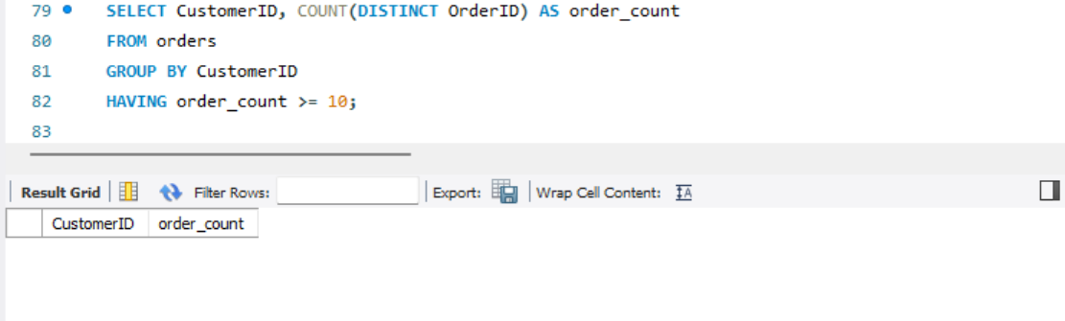

OBSERVATION
The analysis revealed that no customers met the eligibility criteria of placing 10 or more orders, as the result set returned empty (as shown in the screenshot).
As a result, no records were updated, and the discount condition could not be applied within the given dataset.

RECOMMENDATION
NIL

- Calculate the average number of days between consecutive orders for customers who have placed at least five orders. (SQL)

APPROACH
To identify such customers, an aggregation query was executed.

*Query & Output as Screenshot is attached *
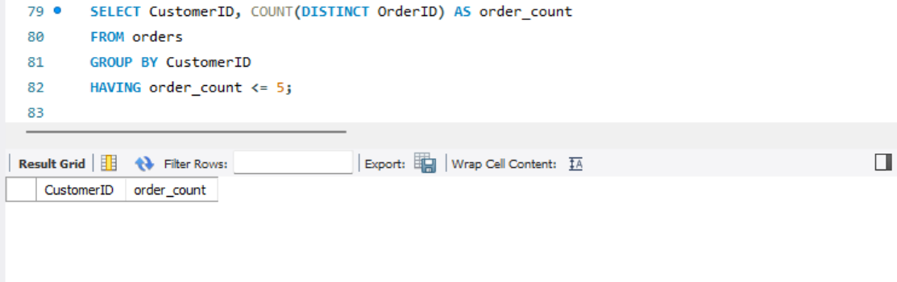

OBSERVATION
The analysis revealed that no customers met the eligibility criteria of placing 5 or more orders, as the result set returned empty (as shown in the screenshot).

As a result, no records were updated, and the discount condition could not be applied within the given dataset.

RECOMMENDATION
NIL
- Calculate the average number of days between consecutive orders for customers who have placed at least five orders. (SQL)
*same question as Q18*
- Calculate the average number of days between consecutive orders for customers who have placed at least five orders. (SQL)
*same question as Q18*
- Identify customers who have generated revenue that is more than 30% higher than the average revenue per customer. (SQL)

APPROACH
To identify high value customers an aggregation query was executed. Customers whose total revenue exceeded 130% of the average revenue were filtered using a comparison condition. The results were sorted in descending order to highlight the highest contributing customers.

*Query as Screenshot is attached *
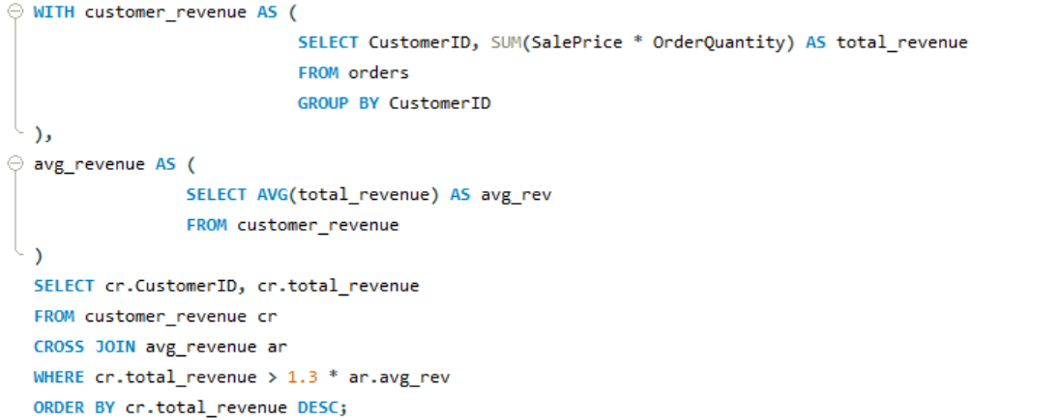

OBSERVATION

*Spreadsheet is attached*

*Output as Screenshot is attached *
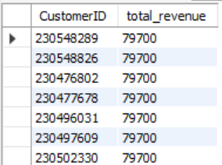

The analysis identified a large number of customers generating revenue significantly above the average. Many customers are clustered within a close revenue range (around 79,000–80,000), indicating consistent high-value transactions across multiple customers rather than a few extreme outliers.

This suggests that revenue distribution is relatively uniform among top customers, with several customers contributing similarly high amounts instead of a highly skewed distribution.

RECOMMENDATION
- Since multiple customers show similar high revenue, implement targeted retention strategies (loyalty programs, personalized offers) to maintain this segment.
- Identify common characteristics (location, category preference) of these customers to replicate acquisition strategies.
- Instead of focusing only on top individuals, create a high-value customer segment for consistent engagement and upselling opportunities.
- Determine the top 3 product categories that have shown the highest increase in sales over the past year compared to the previous year. (SQL)

APPROACH
To identify high value customers an aggregation query was executed.

*Query as Screenshot is attached *
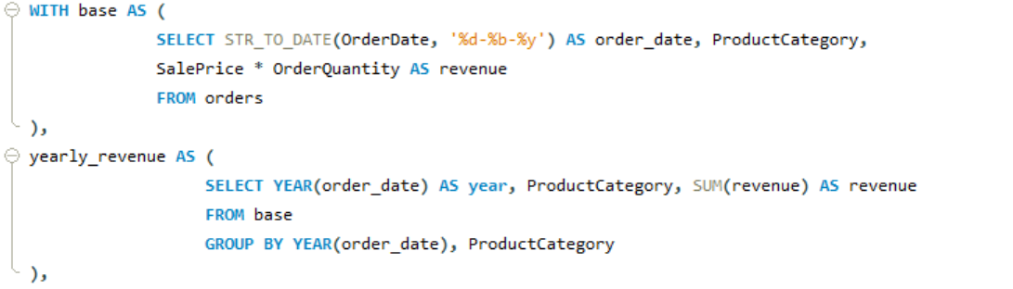
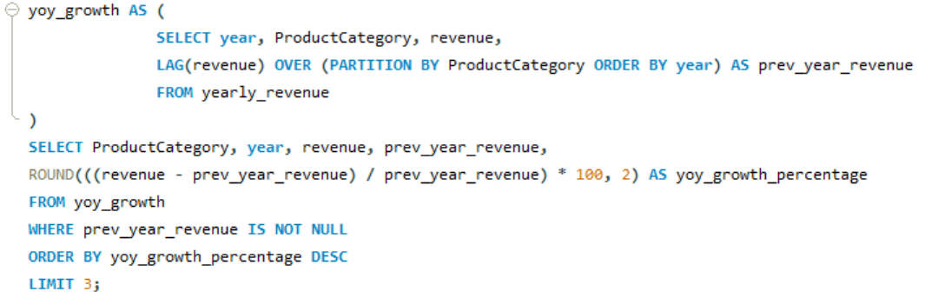

OBSERVATION
The analysis shows that Electronics, Fashion, and Phones & Tablets are the top three categories with the highest year-over-year growth in 2020.
- Electronics recorded the highest growth at 50.37%, indicating a significant increase in demand.
- Fashion followed with 45.93% growth, showing strong upward momentum.
- Phones and Tablet also showed substantial growth at 41.54%, despite already having a high revenue base.
This indicates that multiple categories experienced strong and consistent growth, rather than growth being concentrated in a single segment.

*Output as Screenshot is attached *
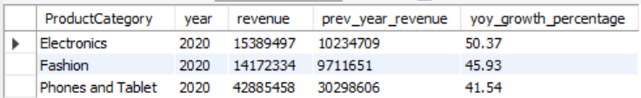

RECOMMENDATION
- Prioritize inventory expansion and marketing efforts in high-growth categories, especially Electronics and Fashion, to capitalize on increasing demand.
- For Phones and Tablets, focus on maintaining growth through pricing strategies and product diversification, as it already operates at a high revenue scale.
- Analyse drivers behind this growth (e.g., customer trends, promotions, external factors) and replicate successful strategies across other categories.

Subjective Question:
- Explain the revenue breakdown by year and by-product. Evaluate how different products contribute to annual revenue and come up with suggestions to increase the sales of the low-selling items.

APPROACH
The analysis was conducted using a stacked column chart in Power BI, where the X-axis represents Year, the Y-axis represents total Revenue, and Product Category is used as the legend. Revenue was calculated as SalePrice × OrderQuantity.

This visualization enables a clear comparison of total annual revenue as well as individual product category contributions within each year, helping identify trends, dominant categories, and underperforming segments.

OBSERVATION
From the graph, it is evident that Phones & Tablets and Fashion consistently dominate revenue contribution across all years, forming the largest portions of each stacked column. Health & Beauty also shows a significant contribution, with noticeable growth in 2020.

In contrast, Electronics and Home & Office occupy smaller portions of the chart, indicating lower contribution to total revenue. The graph also highlights an overall increase in total revenue in 2020, with all categories showing upward movement.

Which could also look like:
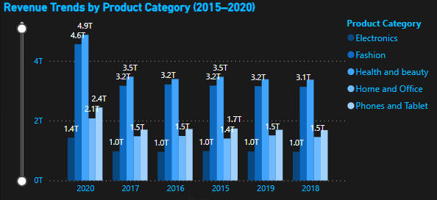
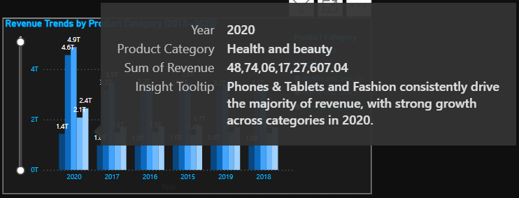

RECOMMENDATION
- Increase focus on low-performing categories (Electronics, Home & Office) through targeted promotions and improved visibility.
- Implement cross-selling strategies, bundling these products with high performing categories like Phones & Tablets.
- Optimize product offerings by identifying underperforming items and improving assortment.
- Leverage insights from high performing categories to replicate successful strategies across weaker segments.
- Continue investing in top categories while ensuring balanced growth across all product segments.

- How many products were returned? Use a DAX function to get this metric. Examine the possible reasons for returns and consider how this metric could indicate improvements in product descriptions or quality control.

APPROACH
To analyze product returns, a DAX measure was created:

Which could also look like:
To identify the underlying causes, a bar chart was created using the Reason column, filtered specifically for returned orders. This enabled a clear breakdown of return reasons and helped highlight the most frequent drivers.

OBSERVATION
- The analysis shows that returns are primarily driven by product defects and delivery-related issues, with defective items and missing or incorrect deliveries being the top contributors.
- Additionally, a significant number of returns are caused by product expectation mismatches, such as sizing issues and discrepancies between product descriptions and actual items.
- This indicates that returns are not random but are largely influenced by quality control gaps, fulfilment inaccuracies, and misalignment between customer expectations and product representation.

Which could also look like:
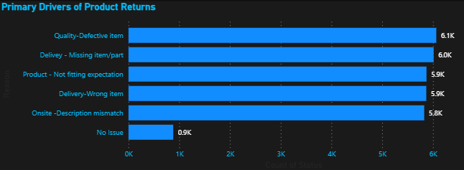
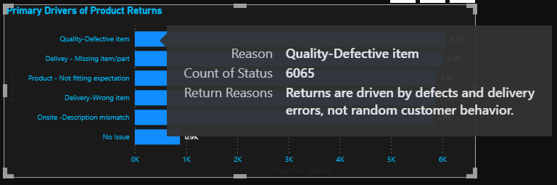

RECOMMENDATION
- Strengthen quality control processes to reduce defective products.
- Improve order fulfilment accuracy and logistics operations to minimize missing or incorrect deliveries.
- Enhance product descriptions, images, and sizing information to reduce expectation mismatches.
- Implement category-specific improvements, particularly for products prone to fit or expectation issues.
- Continuously monitor return reasons to track improvements and reduce return rates over time.

- Whenever a customer goes to Amazon, they’ll filter the most rated products to buy the better category. Can you verify this using any visualization or table that the ratings of products impact their sales value?

APPROACH
To assess whether product ratings influence sales performance, a scatter plot was created in Power BI with average rating on the X-axis and total revenue on the Y-axis, using product categories as the level of comparison.
This visualization helps evaluate whether higher rated categories generate higher revenue, indicating a potential correlation between customer ratings and sales.

OBSERVATION
- The chart shows that average ratings are very similar across all product categories, clustered within a narrow range, while revenue varies significantly.
- Categories like Health & Beauty and Fashion generate the highest revenue, whereas Electronics and Home & Office contribute comparatively lower revenue, despite having nearly identical ratings. Additionally, Phones & Tablets has the highest rating but does not generate the highest revenue.
- This indicates that there is no strong correlation between product ratings and revenue, and that sales are more influenced by category demand and product positioning rather than ratings alone.

Which could also look like:
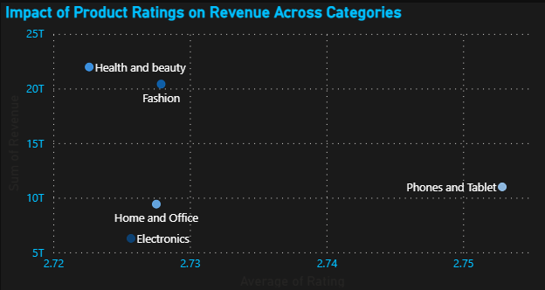

RECOMMENDATION
- Do not rely solely on ratings as a key driver of sales strategy; instead focus on high-demand categories and product positioning.
- Maintain good product ratings to support customer trust, but prioritize pricing, assortment, and marketing strategies to drive revenue.
- Conduct deeper analysis at the product level to identify whether ratings impact sales within specific segments.
- Combine ratings with other factors such as review volume, visibility, and promotions for more effective decision-making.
- Investigate how revenue distribution varies across different locations. Explore which geographical areas contribute most to sales and consider the strategic implications for regional marketing and distribution efforts. How might location-based trends inform the company's market segmentation and resource allocation approach?

APPROACH
Revenue was calculated as SalePrice × OrderQuantity and visualized using a bar chart in Power BI, with locations on the Y-axis and total revenue on the X-axis. The chart was sorted in descending order to clearly compare the contribution of each region and identify top and low-performing locations.

OBSERVATION
- The analysis shows that revenue is highly concentrated in a few key locations, with Greater Accra, Ashanti, and Western contributing the majority of total sales.
- There is a sharp decline in revenue beyond these regions, followed by a long tail of low-performing locations such as Savannah, Oyarifa, and Oti, which contribute minimal revenue. This indicates an uneven geographical distribution, where a few regions dominate while others remain underpenetrated.

Which could also look like:
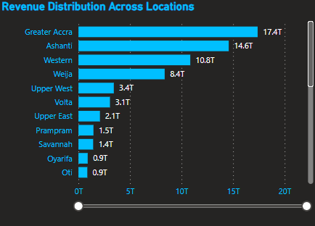

RECOMMENDATION
- Focus on high-performing regions (Greater Accra, Ashanti, Western) to maximize revenue through targeted marketing and retention strategies.
- Develop localized growth strategies for low-performing regions to improve market penetration and customer engagement.
- Use location-based insights to create market segments (high, medium, low performance regions) for better targeting.
- Optimize inventory distribution and logistics planning based on regional demand patterns.
- Allocate resources strategically by balancing investment in dominant markets and expansion into underdeveloped regions.
- Determine which month could benefit from enhanced promotional offers to boost sales. Can you suggest some targeted marketing strategies here?

APPROACH
Monthly revenue was analyzed using a line chart in Power BI, with months on the X-axis and total revenue on the Y-axis. A Month column sorted using Month Number was used to ensure proper chronological order and accurate identification of seasonal trends in revenue.

Which could also look like:

OBSERVATION
- The analysis shows that revenue is highest in the early months, particularly January, March, and May, and declines during the mid-year period.
- The lowest revenue is observed in September, followed by June and November, indicating a consistent dip in performance during the mid-year phase.
- This pattern suggests a seasonal slowdown in demand between June and September, rather than random fluctuations.

Which could also look like:
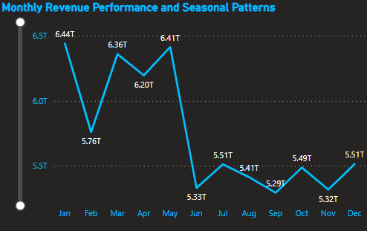

RECOMMENDATION
- Introduce targeted promotional campaigns during low-performing months (June–September) to boost sales.
- Offer seasonal discounts, bundle offers, and limited-time deals to stimulate customer demand.
- Increase marketing efforts and product visibility during mid-year through ads and campaigns.
- Launch category-specific promotions aligned with customer buying patterns during slower months.
- Plan marketing calendars proactively to counter seasonal dips and maintain steady revenue throughout the year.
- Identify which products may require increased marketing efforts. Which items have high prices yet underperform in sales?

APPROACH
To identify underperforming high-priced products, a scatter plot was created in Power BI with Unit Price on the X-axis and Total Revenue on the Y-axis, using product categories as data points.
This visualization helps identify products that are priced high but generate relatively low revenue.

OBSERVATION
- The analysis shows that Electronics has the highest unit price but generates relatively low revenue, indicating poor performance despite premium pricing.
- In contrast, categories like Health & Beauty and Fashion generate significantly higher revenue at lower price levels, demonstrating stronger demand.
- This highlights a clear mismatch between pricing and sales performance, where high-priced products are not translating into higher revenue.

Which could also look like:
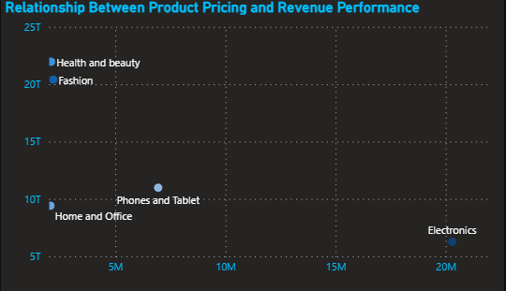

RECOMMENDATION
- Increase marketing efforts for high-priced underperforming categories like Electronics to improve demand.
- Re-evaluate pricing strategy to ensure it aligns with customer willingness to pay.
- Improve product positioning and value communication to justify premium pricing.
- Introduce promotional offers, discounts, or financing options to make high-priced products more attractive.
- Focus on highlighting product features and benefits to enhance perceived value.
- Assess which products should have discounts. How can targeted incentives drive sales and customer loyalty for specific products?

APPROACH
A scatter plot was used to analyze the relationship between Unit Price and Revenue, with reference lines added to divide the chart into performance zones. This segmentation helped identify products that are high-priced but generate relatively low revenue, making them candidates for targeted discounts.

OBSERVATION
- The analysis shows that Electronics falls in the high price, low revenue zone, indicating underperformance despite premium pricing.
- In contrast, categories such as Fashion and Health & Beauty lie in the high-revenue zone, reflecting strong demand at relatively lower price points.
- This highlights a clear price performance imbalance, where certain high-priced products are not effectively converting into revenue.

Which could also look like:
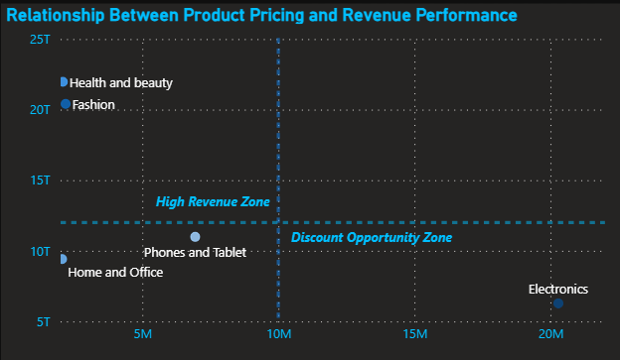

RECOMMENDATION
- Introduce targeted discounts and promotional offers for Electronics to improve sales performance.
- Use bundling strategies, seasonal deals, and EMI options to enhance affordability of high-priced products.
- Strengthen marketing and value communication to justify premium pricing.
- Avoid discounting high-performing categories to maintain profitability.
- Implement personalized offers and loyalty incentives to encourage repeat purchases.
- Targeted incentives can:
- Increase conversion rates for premium products
- Improve customer satisfaction and retention
- Enhance perceived value among customers
- Drive balanced revenue growth across categories

- Come up with a loyalty program to benefit the company’s customers. From the available lot of customers come up with strategies to bucket them and provide benefits under different loyalty programs.

APPROACH
Customers were segmented based on purchasing behavior using key metrics such as order frequency, total revenue contribution, and recency of purchases. This allowed grouping customers into meaningful segments like high-value, loyal, at-risk, and low-engagement customers.

OBSERVATION
The customer base shows clear variation in purchasing behaviour:
- A segment of high value customers contributes a significant portion of revenue, indicating strong loyalty and engagement.
- Loyal customers purchase frequently but may have moderate spending levels.
- Some customers show declining activity (at risk), suggesting potential churn.
- A large portion consists of low-value or occasional customers with limited engagement.
This indicates an opportunity to personalize engagement strategies based on customer value and behaviour.

RECOMMENDATION
- Implement a tiered loyalty program based on customer segments:
- High-value customers: Exclusive rewards, early access, premium benefits
- Loyal customers: Reward points, cashback, referral incentives
- At-risk customers: Personalized offers and re-engagement campaigns
- Low-value customers: Introductory discounts and bundle offer
- Use targeted incentives to increase purchase frequency and customer lifetime value.
- Introduce personalized communication and offers to improve retention and engagement.
- Continuously track customer movement across segments to refine loyalty strategies.
- Using the DAX functions Calculate and a row iteration DAX function calculate the total sales for the Product Category “Fashion” and delivery type “Shipped from Abroad”. What are the other types of DAX functions you have used in the project?

APPROACH
To calculate total sales for the product category “Fashion” and delivery type “Shipped from Abroad”, a DAX measure was created.

Which could also look like:

OTHER DAX FUNCTIONS USED
Aggregation Functions :SUM, COUNT, DISTINCTCOUNT
Logical Functions: IF, SWITCH
Date Functions: MONTH, YEAR, FORMAT
Filter Functions: CALCULATE, FILTER
- Wait Times Correlated with Demographics and Care: Explore how average wait times vary across different product categories to optimize scheduling and staffing.

APPROACH
Average delivery time (DeliveryDays) was analyzed across product categories using a bar chart in Power BI. The metric was aggregated using Average to accurately represent wait times for each category.

OBSERVATION
- The analysis shows that average delivery times are nearly identical across all product categories, with values consistently around 9.5 days.
- This indicates that delivery performance is uniform and not significantly influenced by product category, suggesting a standardized logistics and fulfillment process.

Which could also look like:
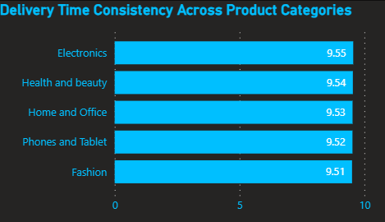

RECOMMENDATION
- Maintain the current standardized delivery system, as it ensures consistent performance across categories.
- Focus on reducing overall delivery time rather than category-specific improvements.
- Further analyze factors such as delivery type or location, which may have a greater impact on wait times.
- Optimize logistics, supplier coordination, and shipping methods to improve overall efficiency and customer satisfaction.
- Explore if there is any relationship between the Delivery type and waiting time between ordering and receiving an item.

APPROACH
To analyze the relationship between delivery type and waiting time (average delivery days), visualized using a bar chart in Power BI, with delivery types on the X-axis and average delivery time on the Y-axis.

OBSERVATION
The analysis shows a clear variation in delivery time across different delivery types:
- Shipped from Abroad has the highest average delivery time (15 days)
- Standard Delivery shows moderate wait time (10 days)
- Express Delivery has the lowest delivery time (3.5 days)

This indicates a strong relationship between delivery type and waiting time, where faster delivery options significantly reduce wait times, while international shipping leads to delays.

Which could also look like:
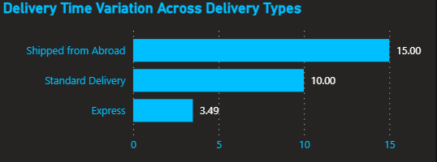

RECOMMENDATION
- Reduce dependency on “Shipped from Abroad” by improving local inventory and sourcing.
- Promote Express Delivery options for customers prioritizing faster service.
- Optimize international logistics and supplier coordination to reduce delays.
- Clearly communicate delivery timelines to manage customer expectations.
- Use delivery type insights to improve operational efficiency and customer satisfaction.

- Is there any relationship between shipping charges and product type?

APPROACH
To examine the relationship between shipping charges and product type, a scatter plot was created in Power BI using Shipping Fee on the X-axis and Revenue on the Y-axis, with product categories as individual data points.

OBSERVATION
The analysis reveals a positive correlation between shipping charges and revenue:
- Health & Beauty and Fashion have the highest shipping fees (0.4M) and also generate the highest revenue (20T+).
- Phones & Tablets fall in the mid-range for both shipping cost and revenue.
- Electronics and Home & Office have lower shipping fees and correspondingly lower revenue.

This indicates that higher performing categories tend to incur higher shipping costs, likely due to higher sales volume or product characteristics such as size or handling requirements.

Which could also look like:
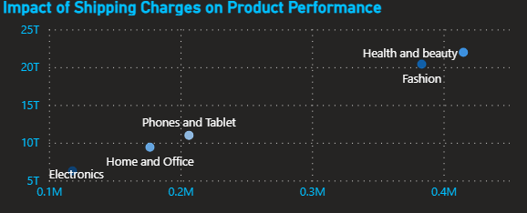

RECOMMENDATION
- Optimize shipping cost efficiency for high revenue categories to improve margins.
- Consider free or subsidized shipping strategies for top performing categories to further boost sales and customer satisfaction.
- Analyse product level shipping cost drivers (weight, size, sourcing) to identify cost-saving opportunities.
- Ensure shipping costs remain competitive and do not negatively impact demand.
- Come up with strategies to decrease the low rating orders after analyzing different factors like waiting time, shipping type, unit price, etc.

APPROACH
Low-rating orders were analyzed by examining key influencing factors such as delivery time (DeliveryDays), delivery type, pricing (Unit Price), and return reasons. Insights were derived by correlating multiple visuals, including delivery performance charts, return reason analysis, and pricing vs revenue relationships.

OBSERVATION
The analysis highlights several key drivers of low ratings:
- Long delivery times negatively impact customer satisfaction, especially for orders “Shipped from Abroad”

Which could also look like:


- Product related issues (defective items, wrong deliveries, description mismatch) are major contributors to dissatisfaction

Which could also look like:
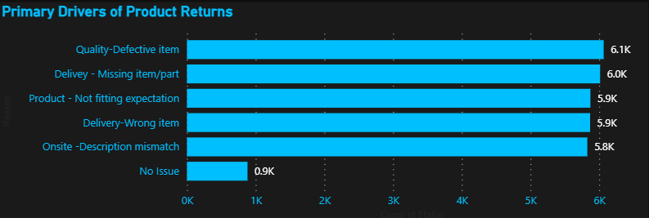

- High priced products like Electronics show lower performance, indicating poor value perception

Which could also look like:

RECOMMENDATION
Improve delivery performance by:
- Reducing reliance on “Shipped from Abroad” logistics
- Increasing local inventory availability
- Promoting Express delivery options
Enhance product quality and accuracy by:
- Strengthening quality control processes
- Ensuring accurate product descriptions and images
Reduce returns and dissatisfaction by:
- Improving order accuracy and packaging
- Continuously analyzing return reasons for process improvements
Enhance customer experience by:
- Providing real time tracking and transparent delivery timelines
- Offering personalized support and loyalty incentives
- Using the time intelligence DAX function, create a table to compare each month’s sales with the previous year’s same month’s total sales. So there will be four columns in the output year, month, total sales, previous_years_sales.

APPROACH
Time intelligence DAX functions were used to compare monthly sales with the same period in the previous year. A base measure for total sales was created, followed by a previous year sales measure using the SAMEPERIODLASTYEAR function.

Which could also look like:

OBSERVATION
- The table shows month wise sales comparison across years, allowing clear tracking of performance trends.
- For the first year (2015), data is blank, as no prior data exists.
- This structure helps identify seasonal patterns and year-over-year growth or decline.

Which could also look like:
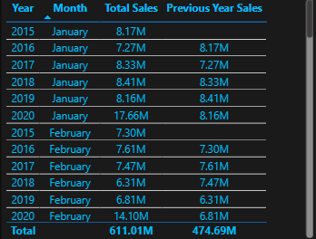

RECOMMENDATION
- Use this analysis to monitor monthly performance trends and seasonality.
- Identify months with declining sales and implement targeted promotions or strategies.
- Leverage YoY comparisons for forecasting, planning, and business decision making.
- What do you understand by PowerBI gateway? What are its use cases?

Power BI Gateway is a secure bridge that connects on-premises data sources to Power BI Service, enabling data access without moving it to the cloud.

TYPES
- Personal Gateway – For individual use, supports scheduled refresh.
- Enterprise Gateway – For organizations, supports multiple users, live connections, and centralized data access.

USE CASES
- Scheduled data refresh for on-premises data.
- Live connection to databases like SQL Server.
- Secure access to local data from the cloud.
- Enabling enterprise-level reporting and data sharing.
- How would you approach this problem, if the objective and subjective questions weren't given?

If no predefined questions were provided, I would start with an exploratory data analysis approach to understand the dataset and identify key business insights.
- Understand the data
- Review data structure, columns, and data types
- Perform data cleaning and handle missing values

- Define key metrics
- Revenue, Order Quantity, Ratings, Delivery Time, Returns

- Perform exploratory analysis
- Analyze trends over time (monthly/yearly sales)
- Identify top-performing and underperforming categories
- Examine relationships (e.g., price vs revenue, delivery time vs ratings)
- Identify patterns and issues
- High return reasons
- Delivery delays
- Customer behavior trends

- Create visualizations
- Use charts (bar, line, scatter) to uncover insights

Report:
The stakeholders have asked for three tabs in the Reporting:
- Main Tab
- Product Tab
- Individual product Tab

- Using the Main tab in the Report, Stakeholders should be able to look at the total sales, revenue produced till now, and customer satisfaction for all product categories. This tab should have a slicer of product category and date.
- Using the product Tab, the management at the company should be able to look at the individual product category-wise performance like customer satisfaction, the number of customers purchasing that product, and which product requires improvement. This tab should have a slicer of gender, delivery type, product category, and age group
- Using the Individual product Tab, the Management and Stakeholder in the company want to look at the best product profile which would involve their total purchase, ID of that product, category/subcategory of that product, average rating, and how much revenue was generated by this product. All the metrics using which they can address the product very carefully in their orders.

Make sure that all the visualizations look decent and are placed in a proper order. Each tab has different POCs (Point Of Contact), so make sure you involve all the metrics that POC may look at in that tab along with those mentioned in the tab description.

